Candise Curlee
Communications Director
Friends of Mimosa Hall & Gardens
678-330-0307
candise@friendsofmimosa.org

FOR IMMEDIATE RELEASE
Friends of Mimosa Hall & Gardens Offers Snowball Bushes to Celebrate Earth Day and Historic Preservation Month (May 2020) to Raise Funds for Restoring Famed Gardens and Installing Solar Roof.
ROSWELL, GA: On April 22nd, Friends of Mimosa Hall & Gardens celebrated the 50th Anniversary of Earth Day with Roswell and greater Atlanta citizens in honor of decades of global sustainability efforts. Earth Day activities included sharing awareness of the solar roof project currently underway at the property, as well as building community in these unprecedented times of global pandemic.
Atlanta-area residents and Mimosa Hall patrons pulled on their gardening gloves and shared beautiful photos and videos of themselves and family members planting trees and seedlings at their homes, all while practicing safe social distancing. These cherished family moments helped share the importance of sustainability and can be viewed as part of the Friends’ Virtual Earth Day Commemorative Video!
Friends’ celebration continues from the 50th anniversary of Earth Day (April 22, 2020) into May 2020 as the National Trust spotlights Historic Preservation Month, which demonstrates the social and economic benefits of historic preservation.
Gorgeous Snowball Bushes to Grow with Your Family
To honor the 50th Anniversary of Earth Day this spring, as well as to celebrate May 2020 as the National Historic Preservation Month, Friends of Mimosa Hall and Gardens have partnered with Twin Branch Nursery & Landscape to offer a commemorative snowball bush for a $50 donation. Please visit our website at www.FriendsofMimosa.org to order yours today!
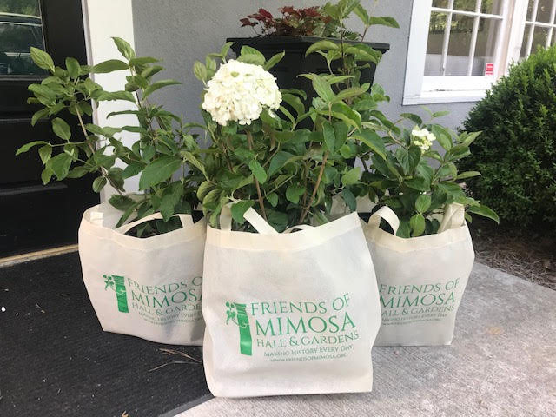

No credit needed for photo
About Mimosa Hall’s Solar Roof Project – Currently Underway
Architect Simone du Boise of Cadmus Construction will be implementing restoration designs for the property to integrate cutting-edge thin-film solar power into Mimosa Hall’s roofline -- when completed, Mimosa Hall will own the title of “The Oldest Net Zero Building in the United States!”
To find out more about the efforts of Friends of Mimosa Hall and Gardens to make Mimosa Hall the oldest Net Zero house in America, please check out their website. Also, be sure to learn about their new integrated alternative energy system for solar power and alternative efforts here.

About Mimosa Hall and Gardens: Mimosa Hall was built in 1841 as one of the first permanent homes in Roswell. In 1918, Atlanta architect J. Neel Reid purchased the property and installed 5 acres of formal garden “rooms”. Mimosa remained in private hands until 2017, when it was purchased by the City of Roswell. Friends of Mimosa Hall & Gardens is currently fundraising to help the City restore both the house and the Reid gardens. In August 2018, Friends of Mimosa was awarded the Historic Landscape Preservation Grant from the Garden Club of Georgia to restore Reid’s reflecting pool. For more information, visit FriendsOfMimosa.org.

